The Modified Water Fall method is a derivative of the traditional water fall model but with some minor variations relative to iterations between certain stages.
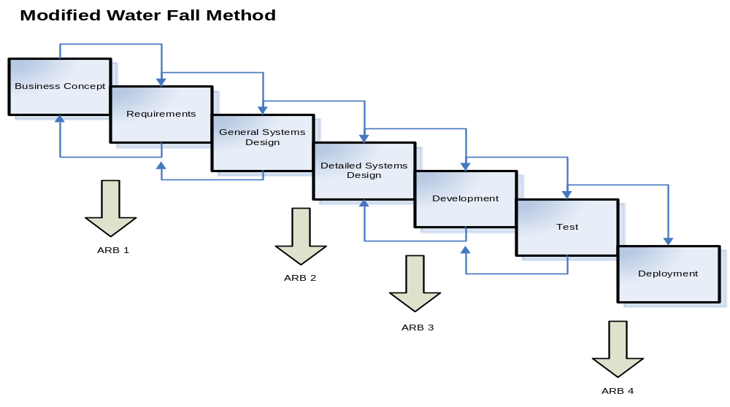
Figure 1

Looking at the MWF model graphic (Figure 1), this presumes that the development team has coordinated with the business and technical entities to define both functional and non-functional requirements. This can be an iterative process to clearly define, exhaustively scrub, categorize, and prioritize all requirements prior to starting the General Systems Design (GSD) phase. The General Design phase is the first interpretation and translation of these requirements into systems conceptual designs and architecture models. During the GSD phase, the requirements are validated and finalized which is probably the most important step towards project success. Through the GSD and ARB 2 processes, the technical team has established and confirmed a mutual understanding and agreement of all the requirements as well as the solutions design and architectural approaches. Changes in requirements beyond the GSD, constitute a change in scope typically invoking the change control process. Hence, all requirements must be finalized before the Detailed Systems Design (DSD) phase begins in the MWF method. The DSD is the detailed blueprint on how the solution will be architected and constructed. The development team shall design and architect the solution as outlined in the DSD. Any problems or issues discovered during the subsequent phases (Development and Testing) that require major changes and/or deviations in the DSD relative to technology, system’s architecture and/or functionality, pre-defined requirements, or schedule changes will require an ARB 3. Testing phase is all encompassing to include the following: test planning document, unit testing, module testing, systems integration testing, regression testing, user acceptance testing, load and performance testing, and software security vulnerability testing with integrated software quality assurance processes that link to requirements traceability and defect logging, tracking, and resolution. The UAT sign-off, security certificate, final test results and ARB 4 endorsement are the necessary check points to proceed to the deployment phase. A detailed implementation playbook, resource alignment, and production readiness report are required to complete the migration into the live production environments and begin the deployment process. The MWF method requires specific deliverables (e.g., Project Management and SDLC), integration points with business and BIS staff, and sequential review periods for solution deliverables throughout the project life cycle.
Nevertheless, the graphic illustrates a few critical principles of a good methodology:
- Work is done in stages primarily in sequence with some minor iterations,
- Content reviews are conducted between certain stages, and
- Reviews represent quality gates, check-points, and decision points for continuing to the next SDLC phase.
The modified waterfall provides an orderly sequence of development steps with some flexible iterative stages to facilitate the adequacy of documentation and design reviews to ensure the quality, reliability, and maintainability of the developed custom software. The MWF method is the preferred method of choice for highly complex and technology intensive custom software development project initiatives.

